|  |
| --- |
| Static Aint Always Noise *20pts general skills* |
| Description:  Can you look at the data in this binary: static? This BASH script might help! |

1. Download the files given in the description.
2. *cd* into the folder where the downloads are.
3. Make the bash script (“ltdis.sh”) executable in one of two ways:
   1. type in *chmod +x ltdis.sh*
   2. in folder right click “ltdis.sh” 🡪 properties 🡪 permissions 🡪 checkmark “allow executing file as program”
4. Type in the terminal command *./ltdis.sh static*
   1. A file “static.ltdis.strings.txt” should have been created.
5. Type in the terminal command *cat static.ltdis.strings.txt*
   1. The flag is on the 16th line of the file.

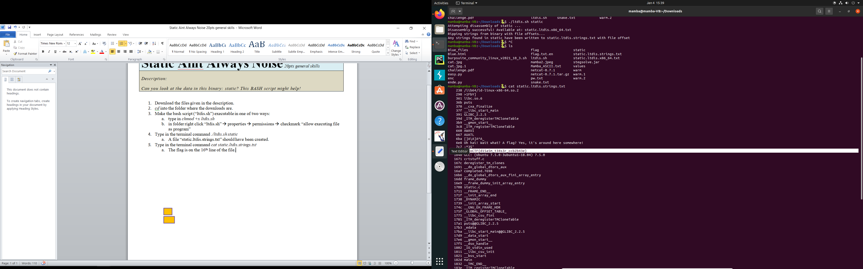

5a

5

4a

4